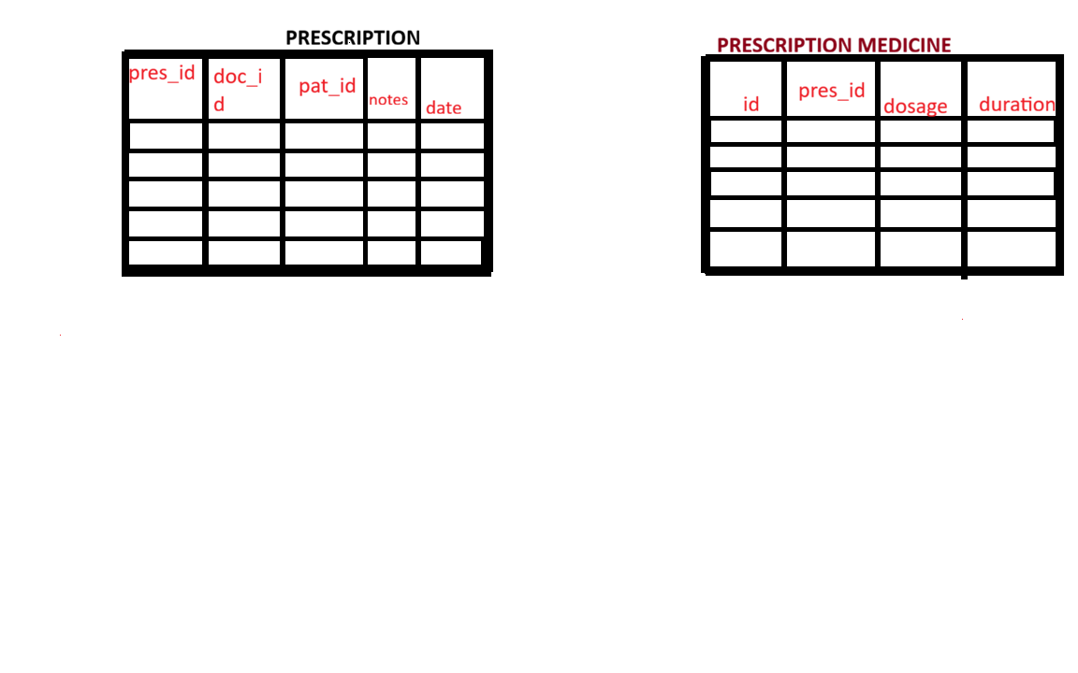Your diagram is showing a Parent-Child relationship.
Table 1: Prescription (Parent)
+--------------------------------------------------+
| PRESCRIPTION |
+--------------------------------------------------+
| pres_id (PK) |
| doc_id |
| pat_id |
| notes |
| date |
+--------------------------------------------------+
Example data:
pres_id | doc_id | pat_id | notes | date
101 | 501 | 1001 | Mild fever | 2026-06-12

Table 2: Prescription_Medicine (Child)
+--------------------------------------------------+
| PRESCRIPTION_MEDICINE |
+--------------------------------------------------+
| id (PK) |
| pres_id (FK) |
| medicine_id |
| dosage |
| duration |
| quantity |
+--------------------------------------------------+
Example data:
id | pres_id | medicine_id | dosage | duration
1 | 101 | 1 | 1 Tablet | 5 Days
2 | 101 | 2 | 2 Tablets | 7 Days

Notice:
pres_id = 101
appears in both medicine rows.
That means:
Prescription 101
|
+-- Medicine 1
|
+-- Medicine 2

What happens when API receives request?
Request:
{
"patientId": 1001,
"doctorId": 501,
"prescriptionDate": "2026-06-12",
"medicines": [
{
"medicineId": 1,
"dosage": "1 Tablet",
"duration": "5 Days"
},
{
"medicineId": 2,
"dosage": "2 Tablets",
"duration": "7 Days"
}
],
"notes": "Patient has mild fever"
}

Step 1: Create Prescription Object
Service creates:
Prescription prescription = new Prescription();
prescription.setPatientId(1001);
prescription.setDoctorId(501);
prescription.setNotes("Patient has mild fever");
At this point:
prescriptionId = null
because it hasn't been saved yet.

Step 2: Create Child Objects
Loop through medicines:
for(PrescriptionMedicineRequestDTO dto : request.getMedicines())
First iteration:
PrescriptionMedicines medicine1 =
new PrescriptionMedicines();
medicine1.setMedicineId(1);
medicine1.setDosage("1 Tablet");
Second iteration:
PrescriptionMedicines medicine2 =
new PrescriptionMedicines();
medicine2.setMedicineId(2);
medicine2.setDosage("2 Tablets");

Step 3: Connect Child to Parent
Very important:
medicine1.setPrescription(prescription);
medicine2.setPrescription(prescription);
Now memory looks like:
Prescription
|
+-- Medicine1
|
+-- Medicine2

Step 4: Add Children to Parent
prescription.getMedicines().add(medicine1);
prescription.getMedicines().add(medicine2);
Now:
Prescription
|
+-- Medicine1
|
+-- Medicine2
exists completely in Java memory.

Step 5: Save Parent
prescriptionRepository.save(prescription);
Because you have:
@OneToMany(
mappedBy = "prescription",
cascade = CascadeType.ALL
)
Hibernate does:
First
INSERT INTO prescription
(patient_id, doctor_id, notes)
VALUES
(1001,501,'Patient has mild fever');
Generated id:
pres_id = 101

Then
Hibernate automatically inserts:
INSERT INTO prescription_medicine
(pres_id, medicine_id, dosage)
VALUES
(101,1,'1 Tablet');
and
INSERT INTO prescription_medicine
(pres_id, medicine_id, dosage)
VALUES
(101,2,'2 Tablets');

Why do we set both sides?
In Parent:
prescription.getMedicines().add(medicine);
In Child:
medicine.setPrescription(prescription);
Both are needed.
Without:
medicine.setPrescription(prescription);
Hibernate doesn't know what value to put in:
pres_id
inside prescription_medicine.

Entity Mapping
Prescription
@OneToMany(
mappedBy = "prescription",
cascade = CascadeType.ALL,
orphanRemoval = true
)
private List<PrescriptionMedicines> medicines;
PrescriptionMedicines
@ManyToOne
@JoinColumn(name = "pres_id")
private Prescription prescription;
This tells Hibernate:
Prescription (1)
|
|
V
PrescriptionMedicine (Many)

Final Database State
prescription
pres_id | patient_id | doctor_id
101 | 1001 | 501
prescription_medicine
id | pres_id | medicine_id
1 | 101 | 1
2 | 101 | 2
So your service should only save the parent (Prescription), and because of CascadeType.ALL, Hibernate will automatically save all rows in PrescriptionMedicine as long as you properly set:
medicine.setPrescription(prescription);
prescription.getMedicines().add(medicine);
before calling:
prescriptionRepository.save(prescription);

